**CHAPTER - 2 : PIXELS AND THEIR RELATIONSHIPS**

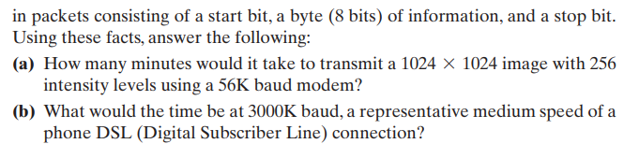

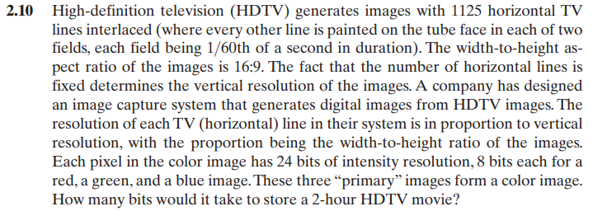

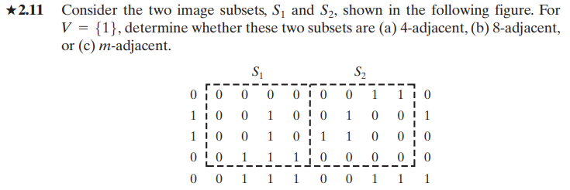





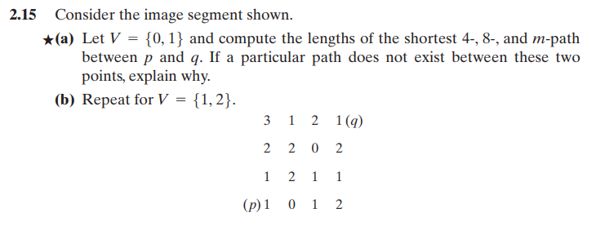

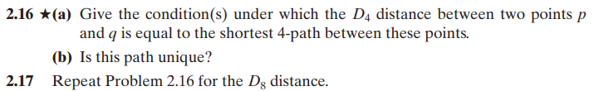

**CHAPTER - 3 : INTENSITY TRANSFORMATIONS**



